Self Advocacy Technical Assistance Center
(SARTAC)
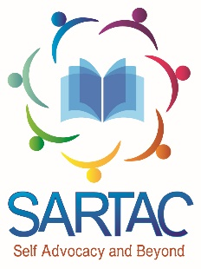
Hosts
PEER-TO-PEER CONNECTIONS
CALLS TO KEEP PEOPLE WITH ID/DD
INFORMED ABOUT COVID-19
EVERY MONDAY AND THURSDAY
- 1:00 ET
- 12:00 CT
- 11:00 MT
- 10:00 PT
The call provides a safe place for People with I/DD to share
Their thoughts, feelings, questions and fears with peers
And share information in plain language
To join on computer, tablet or smart phone - https://zoom.us/j/324815633
Or call 1-929-436-2866 and the Meeting ID: 324 815 633

