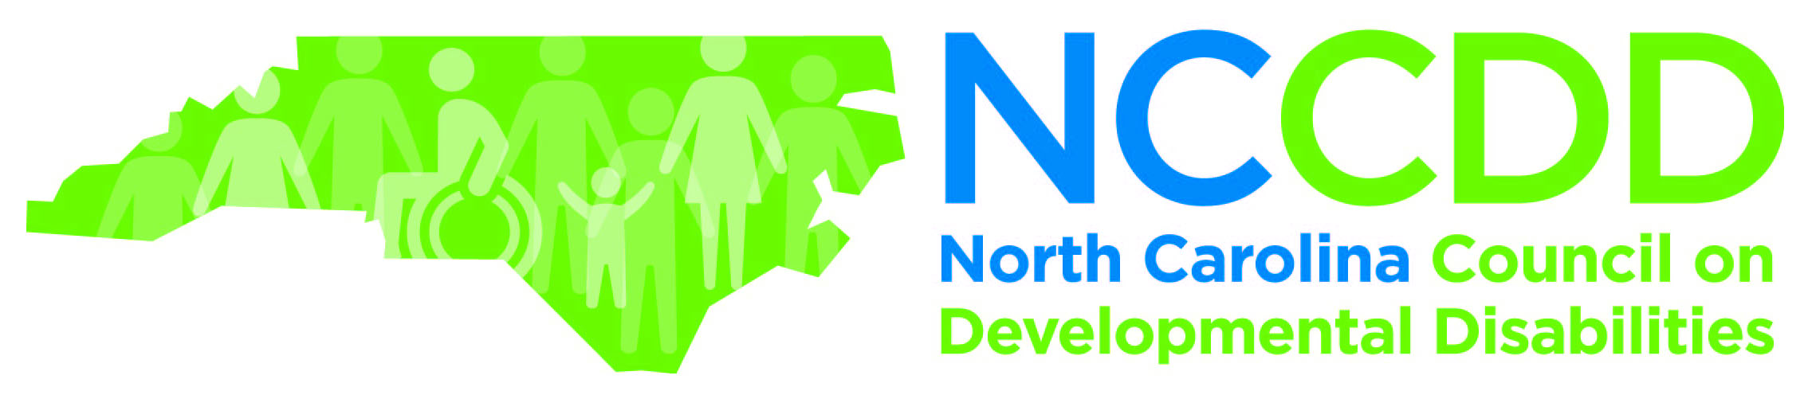
NCCDD CONFERENCE FUNDING REQUEST

Mail to: NCCDD, 3125 Poplarwood Ct., Raleigh, NC 27604 or e-mail: joann.toomey@dhhs.nc.gov

NAME OF AGENCY MAKING REQUEST:

MAIN CONTACT:
NAME:
AGENCY ADDRESS:
EMAIL ADDRESS:
TELEPHONE:

CONFERENCE TITLE AND BRIEF DESCRIPTION OF EVENT OBJECTIVE:
(Attach Conference Brochure if available)

DATE(S) OF CONFERENCE:

CONFERENCE LOCATION: (Conference Center, City)

NAME AND TITLE of SPEAKER(S) PROPOSED FOR NCCDD SPONSORSHIP:

TITLE OF SPEAKER’S PRESENTATION and TOPIC DESCRIPTION:
(Attach bio that includes Contact Information for speaker(s); address, phone # and e-mail)

DATES OF TRAVEL FOR SPEAKER(s): ______________________________________

SPEAKER(s) FEE: (DHHS guidelines allow a maximum of $400/day ($50/hr for up to 8 hrs. Lawyers, physicians, dentists and psychiatrists allow up to $100/hr for up to 8 hrs.)

$________________

COST OF SPEAKER(s) TRAVEL: (Break out costs. Receipts are required for airfare, paid ground transportation and hotel. State rates are subject to change for meals, hotel and mileage. Please contact NCCDD staff for current rates.)

$_________________

COST OF MEETING SPACE: (Break out costs. Receipts are required for meeting rooms, podiums, ramps and accessible audio/visual.)

$_________________

TOTAL REQUESTED: $______________ (Maximum request cannot exceed $3,000)

NOTE: Upon NCCDD approval of request, Agency and speaker will be notified. NCCDD will pay the speaker directly.

NCCDD CONFERENCE FUNDING REQUEST
(Continued)

1. Does the facility where the event will be held meet Americans with Disabilities Act (ADA) requirements for accessibility? Y____ N____

2. Describe the conference planning committee activities focused on ensuring event ADA compliance:

3. Who is the target audience for this presentation/conference?

4. Does the event planning committee include people with intellectual or other developmental disabilities or a family member?
Y____ N____

5. Who are the members of the event planning committee?

6. Describe event activities having implications for systems change, advocacy, and community capacity building:

7. Describe how the event will build or enhance collaboration or partnership with key stakeholders, e.g., people with intellectual or other developmental disabilities, their families, state and other governmental agencies, providers, and the NC ADD Network*:

8. List the names of other agencies, organizations, and individuals providing sponsorship or endorsement of this event:

Upon signature, applicant agrees to acknowledge NCCDD on conference flyers and agendas, dependent on conference size and funding request, waive up to 5 registration fees for NCCDD members or staff.

Submitted by:___________________________________Date_______________________________

*NC ADD Network: North Carolina Administration on Developmental Disabilities Network includes the Carolina Institute for Developmental Disabilities (University Center for Excellence in Developmental Disabilities); Disability Rights North Carolina (NC Protection and Advocacy Organization), and the North Carolina Council on Developmental Disabilities (NCCDD). These three agencies are required by the Developmental Disabilities Bill of Rights and Assistance Act to collaborate to support and assist people with intellectual or other developmental disabilities and their families.

