Media Contact:
Gordon O’Neill, O’Neill Communications
gordon@oneillcommunications.com
Cell: 404-310-6188

Inclusive Workplaces and Innovative Employment
are Keys to Prosperity for People with Disabilities

Facing a huge employment gap between people with disabilities and those without disabilities,
North Carolina employers and disability advocates are working together to make America’s economic promise a reality for everybody, including people with disabilities, according to Alexandra McArthur, chairperson of the North Carolina Council on Developmental Disabilities (NCCDD).

Efforts to promote more inclusive workplaces and employment-oriented educational opportunities are seen as the keys to economic prosperity for people in the disability community. North Carolina Vocational Rehabilitation (NCVR), NC Business Leadership Network (NCBLN) and NCCDD are working together to connect people with disabilities to new job opportunities, provide job-ready skills training or inclusive post-secondary education to help them successfully enter the workforce.

In 2016, NCVR placed a total of 6,494 people with disabilities into jobs in the healthcare, hospitality and personal services area and transportation, manufacturing and construction including business, professional and financial services. Just last month, NCVR had 4,301 pre-qualified “job-ready” candidates with disabilities seeking employment across the state.

“We see immediate and long-term solutions to dramatically reduce the employment gap among people with disabilities,” McArthur said. “In the short run, NCVR offers a large untapped pool of talented people who are ready for immediate employment, while colleges and universities are offering more employment-focused educational opportunities to people with disabilities.”

The EveryBody Works NC campaign is being kicked off during National Disability Employment Awareness Month (NDEAM) and at the NCBLN conference on October 5th in Charlotte. The campaign is educating employers about the untapped talents and potential among people with disabilities while raising career expectations and improving the employability of people with disabilities through participating partners.

Due to the high unemployment rate, people with disabilities are far more likely to live in poverty, depend on government programs and remain socially and economically segregated from their communities and mainstream America than their counterparts. Unemployed people with disabilities include veterans, those with chronic illnesses and people with intellectual and other developmental disabilities (I/DD) that, as potential employees, offer some very attractive attributes.

Businesses and employers are being urged to take note of this untapped labor market among the disability community in North Carolina which includes people with high school diplomas or equivalents and many who have post-secondary educations, certifications and degrees.

-More-

The Institute for Corporate Productivity (ICP) conducted research that concluded employees with disabilities are rated as equally or more productive than their peers. It also found they achieve equal or better overall job performance ratings, reduce turnover rates almost in half and reduce absenteeism when compared to the general workforce.

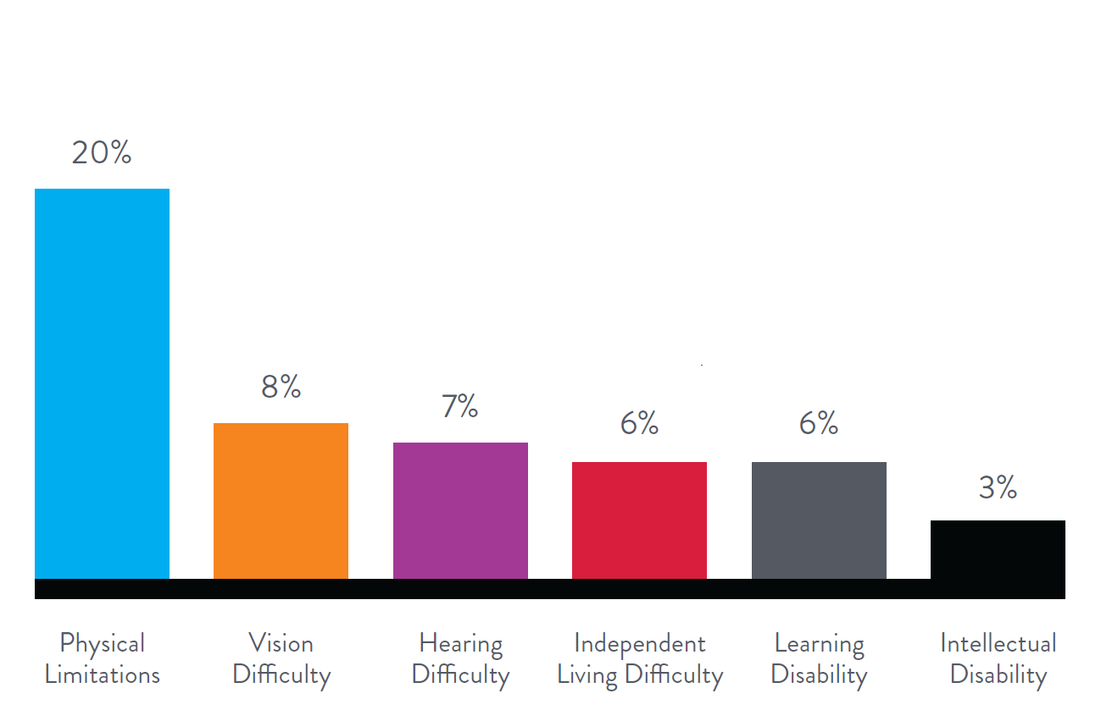
Today, disabilities are affecting one in three households across the country that have at least one household member identified with at least one of the six disabilities illustrated below. The unemployment gap is now impacting more and more households and families and the EveryBody Works NC campaign is focused on finding solutions.

Source: Nielson

Potential employers and employees with disabilities are encourage to contact their local VR office to find new opportunities or, for more information, visit everybodyworksnc.com or ncdhhs.gov/divisions/
dvrs/vr-local-offices.

# # # #

About Everybody Works NC
The Everybody Works NC campaign is increasing awareness of the untapped pool of talent found in the disability community and creating more and more job opportunities for people with disabilities. October is National Disability Employment Awareness Month (NDEAM) which kicks off the year-long EveryBody Works NC campaign with a statewide speaking tour, media relations programs, social media and a series of special events. For more information, visit everybodyworksnc.com.
The campaign is led by the North Carolina Council on Developmental Disabilities (NCCDD), the North Carolina Business Leadership Network (NCBLN) and North Carolina Vocational Rehabilitation (NCVR) to promote and support inclusive workforce strategies.

