A Summer of Accessible Travel in Our State

Do you or a family member or a close friend have a disability? Does the disability make traveling and visiting different tourist attractions more difficult? NCCDD wants you to know that North Carolina has many travel sites that are accessible to people with all types of disabilities. Cannot walk across the beach? No problem – many beaches offer beach wheelchairs or beach access mats. Cannot climb a mountain? You can find accessible mountain pathways and even elevators in the mountains!
Ocean Cure lays down a beach access mat in Carolina Beach every summer and has made beach wheelchairs available for people with mobility disabilities to borrow to help them get across the sand and closer to the water. Meanwhile, Access Wilmington partnered with Ocean Cure to host an event in Carolina Beach in June to help people with disabilities enjoy surfing. Look for July events on Access Wilmington’s calendar at www.accessilm.org.
Not heading to the coast this summer? Perhaps you can cool off in the refreshing mountain air. Grandfather Mountain and Chimney Rock each have an elevator that provides access to people with disabilities who want to enjoy the majestic views on the Mile High Swinging Bridge or the Sky Lounge patio level at Chimney Rock.
Looking for a wheelchair-accessible, sensory-friendly playground to take your kids to? You can find them all across our state from the All-Abilities Playground in Waynesville to Dan Nicholas Park in Salisbury to the Sassafras All Children’s Playground in Raleigh to Harmony Playground in Clayton to Town Common Inclusive Playground in Greenville.
If you are planning a visit somewhere, be sure to check the place’s website for information for visitors with disabilities. For example, the North Carolina Zoo in Asheboro has an Accessibility Needs page with lots of good information from parking to changing tables to sensory needs and more: https://www.nczoo.org/visit/accessibility-needs. If you cannot find the information you are looking for, be sure to call ahead and ask. The more that sites hear from potential visitors with disabilities, the more prepared they will be to accommodate these visitors and their needs.
If you have a great experience somewhere, please let us know. Finally, if you can’t find what you are looking for or the place you want to visit is not accessible enough for you or your family member, consider participating in the Accessibility Challenge to find a solution to make it more accessible to everyone! Safe travels, y’all!

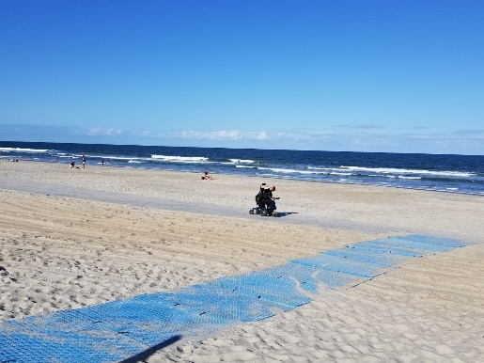
NCCDD member Brendon Hildreth uses the beach access mat at Carolina Beach to move across the sand in his electric wheelchair.

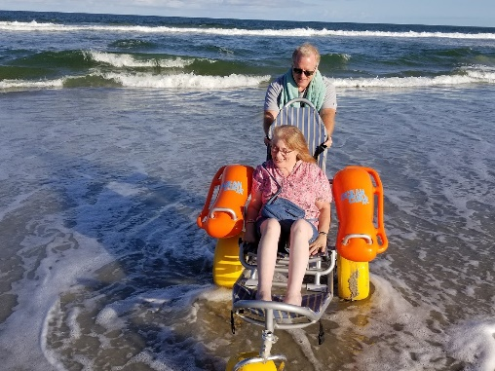
Tim Hildreth, father of NCCDD member Brendon Hildreth, helps NCCDD member Aldea LaParr enjoy using a beach wheelchair in the ocean.

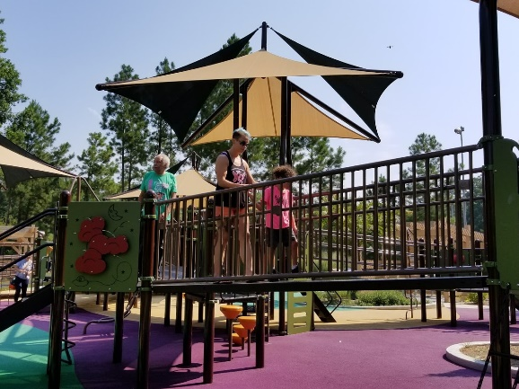
Dorothy Parker and her son Theodore enjoy exploring the Sassafras All Children’s Playground in Raleigh.

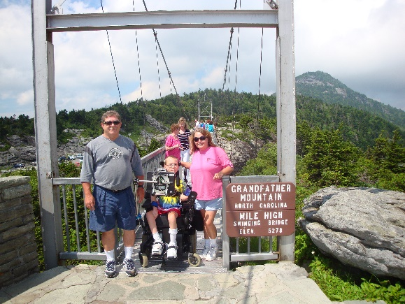
Luke Wilcox and his parents enjoy visiting the Mile High Swinging Bridge.

