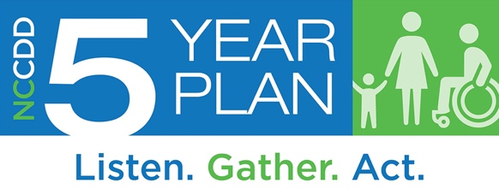
Individual
5-Year Plan Survey
This survey is for individuals with intellectual and other developmental disabilities. The NC Council on Developmental Disabilities wants to hear from you. Your ideas will make a difference as we plan for the next five years. Thank you for filling out this survey.

Before continuing with this survey, please tell us who you are:
- I am an individual with an intellectual or other developmental disability
- I am a family member of a person with a disability
- Other

Feel free to skip any questions you don’t want to answer and use additional paper if needed.

Demographic Questions

Please check below to tell us who you are.
- Age 0-13 years
- Age 14-20 years
- Age 21-25 years
- Age 26-54 years
- Age 55 or over
- Prefer not to say

What is your gender?
- Female
- Male
- Prefer not to say
- Prefer to self-describe: _________________

What is your race or ethnic background?
Check all that apply.
- White
- Black or African American
- American Indian or Alaska Native
- Hispanic/Latin (o) (a) (x)
- Asian
- Native Hawaiian or Pacific Islander
- Unknown
- Prefer not to say

How would you describe your community?
- Urban (medium or large city)
- Suburban (outside the city)
- Rural (fewer people and more open spaces than urban or suburban areas)
- Don’t know
- Prefer not to say

Which region of North Carolina do you live in? (see map of NC Regions)
- Region 1
- Region 2
- Region 3
- Don’t know
- Prefer not to say

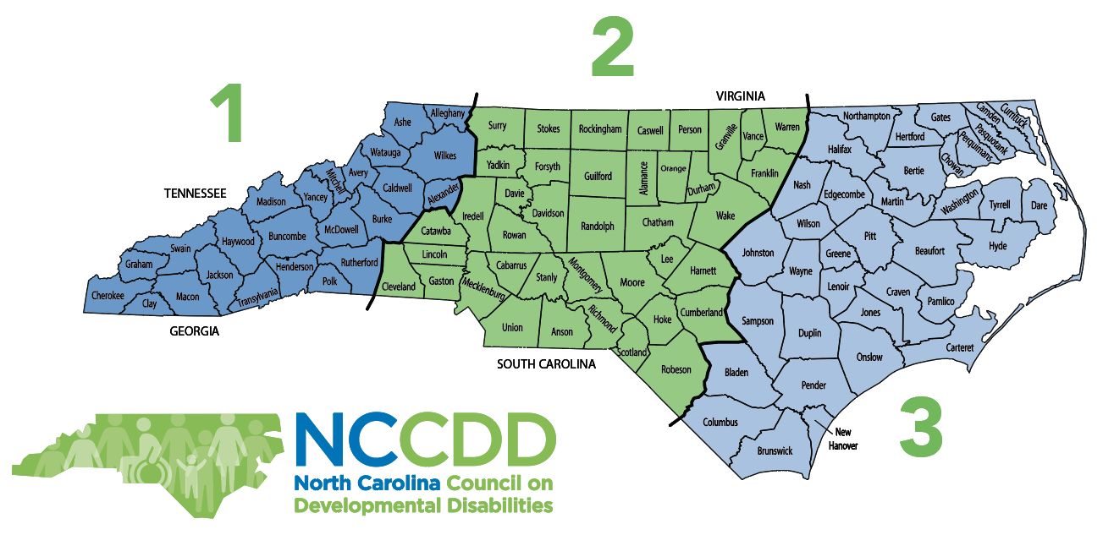

- What do you think are the three (3) most important issues to YOU right now?
Check up to 3.

School | Employment
Housing | Transportation
Money and finances | Planning for my future
Knowing my rights | Self-Advocacy
Knowing what services and supports I can get | Getting the services and supports I need
Getting good medical care | Technology to help me do the activities I want
Living more independently | Helping people with disabilities move out of institutions
Doing more activities I like | Having friends and meaningful relationships
Being more a part of my community | Other (please describe):

Community Services and Supports
- What help do you currently get?
Check all that apply.
- Medicaid Waiver services (Innovations, CAP-C, CAP-DA, TBI)
- State-funded services (non-Medicaid Waiver)
- Help from a family member or friend who isn’t paid
- Technology
- Public school
- Institution (ICF, Nursing Facility)
- Group home
- Help in my family home
- Help in my own home
- Vocational Rehabilitation
- Employment supports not through Vocational Rehabilitation
- Day program
- LME MCO
- Don’t know
- None
- Other help (please describe): ___________________________________
________________________________________________________________________

- If you receive more than one paid service or support, do they work well together?
- No
- Somewhat
- Yes
- I only receive one paid service
- I do not receive paid services
- Don’t know

4) Who most helps you with daily activities? Pick the one that most applies to your situation.
- A family member or friend
- A paid service provider
- A school or day program
- No one helps me, but I need help
- No one helps me, because I do not need help
- Don’t know
- Other (please describe):____________________________________________________
________________________________________________________________________

- Do you currently receive enough support to do what you need and want to do?
- Yes, I have what I need
- No, I need a little more help
- No, I need a lot more help
- No, I need more help almost all the time
- Don’t know/doesn’t apply to me

Technology
Some people are able to participate more in their communities with technology. Examples are iPad, voice-activated e-mail, screen readers, eye-gaze sensors, apps.
6) Do you have the technology you need to participate in community?
- No
- Somewhat
- Yes
- I don’t know enough about what technology might be helpful
- Don’t know/doesn’t apply to me

7) If you said no to the question above, what other technology do you need?: _______________________________________________________________________
________________________________________________________________________

Education and Learning
8. Please tell us about your school activities.
Check all that apply in each row.
 | High School Certificate | High School diploma or GED | Some College Classes | College Degree | Job Training | Day Program | Recreation Classes
Which did they
finish?
Which do they take now?
Which do they want to take in the future?

9) Does/Did your school do a good job of preparing you for adulthood?
- No, a big change is needed
- Some change is needed
- Yes, it’s about right, no change is needed
- Don’t know/doesn’t apply to me

10) How can schools prepare students better for adulthood?
_________________________________________________________________________________
_________________________________________________________________________________

11) Does/Did your school do a good job of preparing you to have a job or go to college?
- No, a big change is needed
- Some change is needed
- Yes, it’s about right, no change is needed
- Don’t know/doesn’t apply to me

Jobs and Money
12) How important is it to you that people with disabilities are paid at least minimum wage ($7.25 an hour) for employment?
- It is very important
- It is somewhat important
- It is not important to me
- Don’t know/doesn’t apply to me

13) Do you have a paid job?
No
Yes
Don’t know/doesn’t apply to me

14) How important is working a paid job to you? Why is it important or not important? ____________________________________________________________ _____________________________________________________________________________
15) If you do NOT have a job, do you have help to find a job?
No
Yes
Don’t know/doesn’t apply to me

16) If you DO have a job, is this a job you want?
No
Yes
Don’t know/doesn’t apply to me

17) If you DO have a job, do you earn minimum wage ($7.25 per hour) or more, and work with people with and without disabilities?
- No
- Yes
- Don’t know/doesn’t apply to me

Health and Wellbeing
18) Do you have friends and caring relationships with people other than support staff and family members?
No, my relationships are with only staff and family
I have one friend/relationship other than staff and family
Yes, I have several friends/relationships with people other than staff and family
Don’t know/doesn’t apply to me

19) Are you able to see a doctor when you need to do so?
Check all that apply.
- No, I do not have insurance.
- No, I cannot afford a doctor
- No, I do not have a doctor to go to
- No, I cannot get to the doctor because of a lack of transportation
- Sometimes
Yes
Don’t know/ doesn’t apply to me

20) Do you think most people who help in emergencies (police officers, firefighters, E.R. staff) know enough about individuals with disabilities?
- No, they need a lot more training
- They need some more training
- Yes, it’s about right
- Don’t know/doesn’t apply to me

Self-Advocacy and Leadership
Self-advocacy means you speak up for yourself, know your rights, advocate, and make your own choices about your life.

21) How do you learn about personal rights? I learn about my rights…
Check all that apply
- From my family
- At school
- From other self-advocates
- At meetings and conferences
- From the North Carolina Council on Developmental Disabilities (NCCDD) and/or other advocacy organizations
- I don't know about rights
- Don't know/doesn't apply to me

22) What would help you be a better self-advocate ?
Check all that apply.
- Training about self-advocacy
- Knowing other self-advocates
- Meetings and conferences about self-advocacy
- Self-advocacy practice at school
- More information and training on disability issues
- Transportation to events and meetings with leaders
- More advocacy events
- Don't know/doesn't apply to me

23) Does your family have enough opportunity to be involved in advocacy?
- No opportunity to be involved
- Some opportunity to be involved
- Yes, enough opportunity to be involved
- Don't know/doesn't apply to me

Home

24) Do you have the housing you need?
- No
- Yes
- Don’t know/doesn’t apply to me

25) How would you describe where you live?
Check all that apply.
- In my own home or apartment
- With one or more family member(s)
- With one or more roommates(s)
- On my own (without roommates)
- In a non-family member's home
- With one or two other people with disabilities
- With 4 to 15 people with disabilities (including myself)
- With 16 or more people with disabilities (including myself)
- I don't have a regular place to stay
- Don't know/doesn't apply to me

26) Did you choose where you live?
No, I don’t have a choice
- I had some input but someone helped me choose
- Yes, I chose for myself
- Don’t know/doesn’t apply to me

27) Did you choose the people you live with?
- No, I didn't have a choice
- I had some input but someone helped me choose
- Yes, I chose them myself
- I live on my own
- Don't know/doesn't apply to me

28) How could housing for people with disabilities be better in your community?
_____________________________________________________________________
____________________________________________________________________________________

Transportation
29) Do you have the transportation to get where you want and need to go?
- Never
- Hardly ever
- Sometimes
- Most of the time
- Always
- Don’t know/doesn’t apply to me

30) How could transportation for people with disabilities be better in your community?

_______________________________________________________________________________
_______________________________________________________________________________

Follow-Up to This Survey:
What are three (3) things you would most like to change or improve for people with disabilities in North Carolina?

Type one or two words on each line.
1. ______________________________________________________________________________________
2. ______________________________________________________________________________________
3. ______________________________________________________________________________________

Did these questions let us know what is important to you?
- No, they did not
- Some questions did
- Yes, they did
- Don’t know/doesn’t apply to me

Additional Comments – What Do We Need to Know
_________________________________________________________________________________________
_________________________________________________________________________________________
_________________________________________________________________________________________
_________________________________________________________________________________________
_________________________________________________________________________________________

COVID-19 Emergency
As we developed this survey, the COVID-19 (coronavirus) emergency was beginning in North Carolina. Please tell us anything we need to know about your experience. For example, have you had all the help and information you needed? If not, what else have you needed?
_______________________________________________________________________________________
_______________________________________________________________________________________
________________________________________________________________________________________

_______________________________________________________________________________________
_______________________________________________________________________________________
________________________________________________________________________________________

_______________________________________________________________________________________
_______________________________________________________________________________________
________________________________________________________________________________________

Thank you again for your participation in our survey. We value and appreciate your input.
If you would like to request a different survey format or if you have questions about the 5 Year State Plan development process, please contact David Ingram at 1-800-357-6916 or David.Ingram@dhhs.nc.gov. This effort is supported by NCCDD and funds it receives through P.L. 106-402, the Developmental Disabilities Assistance and Bill of Rights Act of October 2000.

Please email the completed form to: NCFYP@nccdd.org
or mail to:
North Carolina Council on Developmental Disabilities
ATTN: Five Year Plan
2010 Mail Service Center
Raleigh, NC 27699

