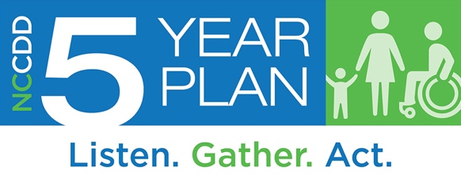
Family Members
5-Year Plan Survey
This survey is for family members of individuals with intellectual and other developmental disabilities. The NC Council on Developmental Disabilities wants to hear from you. Your ideas will make a difference as we plan for the next five years. Thank you for helping us by filling out this survey.

Feel free to skip any questions you don’t want to answer and use additional paper if needed.

Demographic Questions:

Please check below to tell us who you are in relation to your family member(s) with I/DD.
Check all that apply.
- Parent
- Grandparent
- Guardian (not biologically related)
- Child of
- Sibling
- Spouse
- Other family member

Does a family member with I/DD live with you?
- No
- Sometimes, but not all the time
- Yes, or most of the time
- Prefer not to answer

What is the age of your family member with I/DD?
If you have more than one family member with I/DD, you may check more than one box.
- Age 0-13 years
- Age 14-20 years
- Age 21-25 years
- Age 26-54 years
- Age 55 or over
- Prefer not to say

What is the gender of your family member(s) with I/DD?
If you have more than one family member with I/DD, you may check more than one box.
- Female
- Male
- Prefer not to say
- Prefer to self-describe: _________________

What is your family member’s race or ethnic background?
Check all that apply.
- White
- Black or African American
- American Indian or Alaska Native
- Hispanic/Latin (o) (a) (x)
- Asian
- Native Hawaiian or Another Pacific Islander
- Unknown
- Prefer not to answer

How would you describe the community of your family member(s) with I/DD?
If you have more than one family member with I/DD, you may check more than one box.
- Urban (medium or large city)
- Suburban (outside the city)
- Rural (fewer people and more open spaces than urban or suburban areas)
- Don’t know
- Prefer not to say

Which region of North Carolina does your family member live in? (See map of NC regions below.)
If you have more than one family member with I/DD, you may check more than one box.
- Region 1
- Region 2
- Region 3
- Don’t know
- Prefer not to say

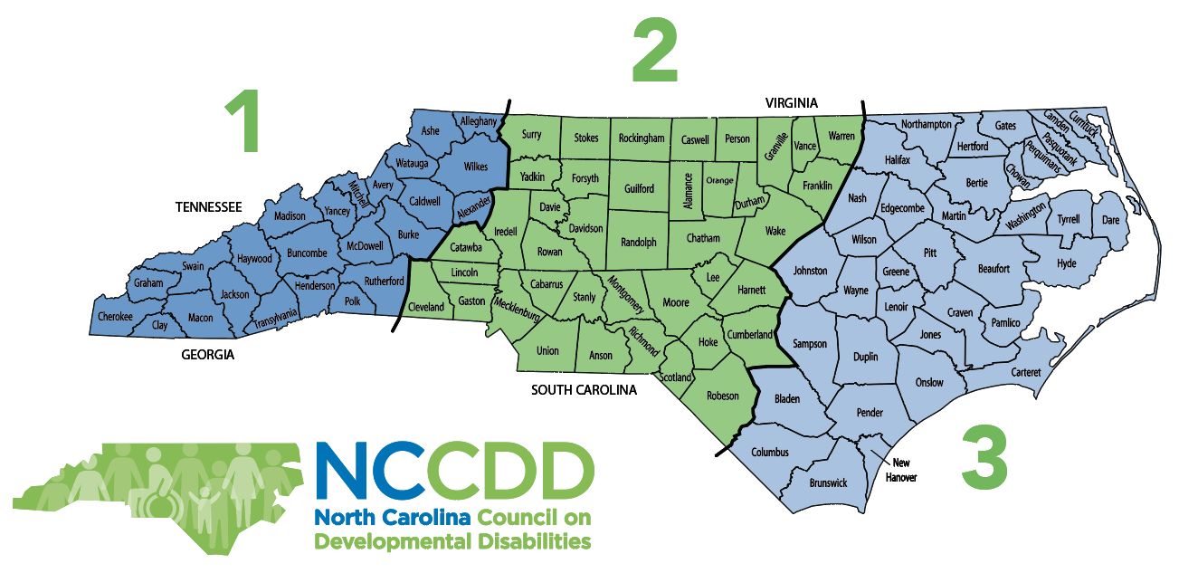

- What do you think are the three (3) most important issues for people with I/DD in North Carolina right now?
Check up to 3.

School | Employment
Housing | Transportation
Money and finances | Planning for the future
Knowing their rights | Self-Advocacy
Knowing what services and supports are available | Getting the services and supports they need
Getting good medical care | Technology to help them do the activities they want
Living more independently | Helping people with disabilities move out of institutions
Doing more activities they like | Having friends and meaningful relationships
Being more a part of the community | Other (please describe):

Community Services and Supports
2) What type of services and supports does your family member with I/DD currently receive? Check all that apply.
- Medicaid Waiver-funded services (Innovations, CAP-C, CAP-DA, TBI)
- State-funded services (non-Medicaid Waiver)
- Help from a family member or friend who isn’t paid
- Technology
- Public school
- Institution (ICF, Nursing Facility)
- Group home
- Help in family home
- Help in own home
- Vocational Rehabilitation
- Employment supports not through Vocational Rehabilitation
- Day program
- LME MCO
- Don’t know
- None
- Other help (please describe): ___________________________________
________________________________________________________________________

- If your family receives more than one paid service and support, do they work well together?
- No
- Somewhat
- Yes
- Family member only receives one paid service
- Family member does not receive paid services
- Don’t know

4) Who most helps your family member(s) with I/DD with daily activities? Pick the box that most applies to their situation.
- A family member or friend
- A paid service provider
- A school or day program
- No one helps, because they do not need help
- No one helps, but help is needed
- I don’t know.
- Other (please describe): ____________________________________________________
________________________________________________________________________

- Does your family member with I/DD currently receive enough support to do what they need and want to do?
- Yes, my family member has what is needed
- No, my family member needs a little more help
- No, my family member needs a lot more help
- No, my family member needs more help almost all the time
- Don’t know/doesn’t apply to me

Technology
Some people are able to participate more in their communities with technology. Examples are iPad, voice-activated e-mail, screen readers, eye-gaze sensors, apps.

6) Does your family member with I/DD have the technology they need to participate in the community?
- No
- Somewhat
- Yes
- I don’t know enough about what technology might be helpful
- Don’t know/doesn’t apply to me

7) If you said no to the question above, what other technology is needed?: _______________________________________________________________________
________________________________________________________________________

Education and Learning
8. Please tell us about your family member’s school activities.
Check all that apply in each row.
 | High School Certificate | High School diploma or GED | Some College Classes | College Degree | Job Training | Day Program | Recreation Classes
Which did they
finish?
Which do they take now?
Which do they want to take in the future?

9) Does/Did your family member’s school do a good job of preparing them for adulthood?
- No, a big change is needed
- Some change is needed
- Yes, it’s about right – no change is needed
- Don’t know/doesn’t apply

10) How can schools prepare students better for adulthood?
_________________________________________________________________________________
_________________________________________________________________________________
11) Does/Did your family member’s school do a good job of preparing them to have a job or go to college?
- No, a big change is needed
- Some change is needed
- Yes, it’s about right – no change is needed
- Don’t know

Jobs and Money
12) How important is it to you that your family member with I/DD be paid at least minimum wage ($7.25 an hour) for employment?
- It is very important
- It is somewhat important
- It is not important to me
- Don’t know/doesn’t apply to me

13) Does your family member with I/DD work at a paid job?
- No
- Yes
- Don’t know/doesn’t apply to my family member

14) How important is it to your family member with I/DD to have a paid job? Why is it important or not important? ____________________________________________________________ _____________________________________________________________________________
15) If your family member with I/DD does NOT have a job, do they have help to find a job?
No
Yes
Don’t know/doesn’t apply

16) If your family member with I/DD DOES have a job, is this a job he/she/they wants?
No
Yes
Don’t know/doesn’t apply

17) If your family member with I/DD DOES have a job, do they earn minimum wage ($7.25 per hour) or more, and work with people with and without disabilities?
- No
- Yes
- Don’t know/doesn’t apply

Health and Wellbeing

18) Does your family member with I/DD have friends and caring relationships with people other than support staff and family members?
- No, my family member only has relationships with staff and family
- My family member has one friend/relationship other than staff and family
- Yes, my family member has several friends/relationships with people other than staff and family
- Don’t know/doesn’t apply to my family member

19) Is your family member with I/DD able to see a doctor when they need to?
Check all that apply.
- No, they do not have insurance
- No, they cannot afford a doctor
- No, they do not have a doctor to go to
- No, they cannot get to the doctor because of a lack of transportation
- Sometimes
Yes
Don’t know/ doesn’t apply to my family member

20) Do you think most emergency personnel (police officers, firefighters, E.R. staff) know enough about working with individuals with I/DD?
- No, they need a lot more training
- They need some more training
- Yes, it’s about right
- Don’t know

Self-Advocacy and Leadership
Self-advocacy means that individuals can speak up for themselves, know their rights, and advocate.

21) How does your family member with I/DD learn about personal rights? My family member with I/DD learns about rights…
Check all that apply.
- From our family
- At school
- From other self-advocates
- At meetings and conferences
- From the North Carolina Council on Developmental Disabilities (NCCDD) and/or other advocacy organizations
- He/she doesn’t know about rights
- Don’t know/doesn’t apply to my family member

22) What would help your family member with I/DD to be a better self-advocate?
Check all that apply.
- Training about self-advocacy
- Knowing other self-advocates
- Meetings and conferences about self-advocacy
- Self-advocacy practice at school
- More information and training on the issues important to people with I/DD
- Transportation to events and meetings with leaders
- More opportunities to advocate at the state, local, and federal level
- Don’t know/doesn’t apply to my family member

23) What would help you be a better advocate on I/DD issues?
Check all that apply.
- Training on advocacy
- Knowing other advocates and self-advocates
- Meetings and conferences about advocacy
- More information and training on disability issues
- Transportation to events and meetings with leaders
- More advocacy events
- Don’t know/doesn’t apply to me

Home

24) Does your family member with I/DD have the kind of housing they need?
- No
- Yes
- Don’t know/doesn’t apply to my family member

25) How would you describe where your family member with I/DD lives?
Check all that apply.
- In own home or apartment
- With one or more family member(s)
- With one or more roommates(s)
- On own (without roommates)
- In a non-family member's home
- With one or two other people with disabilities
- With 4 to 15 people with disabilities (including my family member)
- With 16 or more people with disabilities (including my family member)
- Doesn’t have a regular place to stay
- Don't know/doesn't apply

26) Did your family member with I/DD choose where they currently live?
- No, they didn’t have a choice
- They had some input but someone helped them choose
- Yes, they chose on their own
- Don’t know/doesn’t apply to my family member

27) Did your family member with I/DD choose who they live with?
- No, they didn’t have a choice
- They had some input but someone helped them choose
- Yes, they chose on their own
- Don’t know/doesn’t apply to my family member

28) How could housing for people with disabilities be better in your community?
_____________________________________________________________________
Transportation
29) How often does your family member with I/DD have the transportation to get where he or she wants and needs to go?
- Never
- Hardly ever
- Sometimes
- Most of the time
- Always
- Don’t know/doesn’t apply to my family member

30) How could transportation for people with disabilities be better in your community?

_______________________________________________________________________________
_______________________________________________________________________________

Family Support Services and Advocacy
Many individuals with I/DD live with their families. These families may need services and supports (e.g. respite, family peer services, case management, natural supports) to meet the needs of their family member with I/DD. Families should also have the opportunity to be meaningfully involved in policy and decision making at all levels.

31) Does your family have services and supports?
- Limited or no services or supports
- Some services or supports
- Yes, we have all the services or supports we need
- Don’t know/doesn’t apply to me and my family

32) Do your family have the support you need to plan for the future?
- No, we need support to plan
- We have some support
- Yes, we have about the right support
- Don’t know/doesn’t apply to me and my family

33) Does your family have enough opportunity to be involved in advocating on public policy issues and decisions related to people with I/DD?
- No opportunity to be involved
- Some opportunity to be involved
- Yes, enough opportunity to be involved
- Don’t know/doesn’t apply to my family member

Follow-Up to This Survey:
What are three (3) things you would most like to change or improve for people with disabilities in North Carolina?
Type one or two words on each line.
1. ______________________________________________________________________________________
2. ______________________________________________________________________________________
3. ______________________________________________________________________________________

Did these questions let us know what is important to you?
- No, they did not
- Some questions did
- Yes, they did
- Don’t know/doesn’t apply to me

Additional Comments – What Do We Need to Know
_________________________________________________________________________________________
_________________________________________________________________________________________
_________________________________________________________________________________________
_________________________________________________________________________________________
_________________________________________________________________________________________

COVID-19 Emergency

As we developed this survey, the COVID-19 (coronavirus) emergency was beginning in North Carolina. Please tell us anything we need to know about your experiences and the experience of your family member with I/DD. For example, have you had all the help and information you needed? If not, what else has been needed?
_______________________________________________________________________________________
_______________________________________________________________________________________
________________________________________________________________________________________

_______________________________________________________________________________________
_______________________________________________________________________________________
________________________________________________________________________________________

_______________________________________________________________________________________
_______________________________________________________________________________________
________________________________________________________________________________________

Thank you again for taking our survey. We value and appreciate your input.
If you would like to request a different survey format or if you have questions about the 5 Year State Plan development process, please contact David Ingram at 1-800-357-6916 or David.Ingram@dhhs.nc.gov. This survey was developed by the North Carolina Council on Developmental Disabilities. This effort is supported by NCCDD and funds it received through P.L. 106-402, the Developmental Disability Assistance and Bill of Rights October 2000.

Please email the completed form to: NCFYP@nccdd.org
or mail to:
North Carolina Council on Developmental Disabilities
ATTN: Five Year Plan
2010 Mail Service Center
Raleigh, NC 27699

