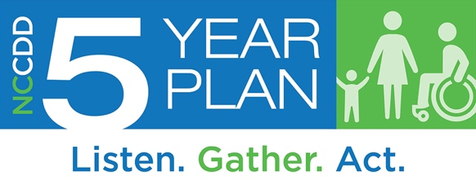
Community Members
5-Year Plan Survey
The NC Council on Developmental Disabilities wants to hear from you. We want to learn about how individuals with intellectual or other developmental disabilities (I/DD) are doing. Your ideas will make a difference as we plan for the next five years. Thank you for helping us by filling out this survey.

Feel free to skip any questions you don’t want to answer and use additional paper if needed.

Demographic Questions

Please check the box the best describes who you are.
Check only one option.
- Provider of I/DD services
- LME/MCO staff
- Employer of a person with I/DD
- State employee working within the field of I/DD
- I/DD advocate
- I/DD educator
- Other, please specify: ________________________________________

What ages of people with I/DD do you work with or advocate for?
Check all that apply.
- Age 0-13 years
- Age 14-20 years
- Age 21-25 years
- Age 26-54 years
- Age 55 or over
- Prefer not to say

What is your gender?
- Female
- Male
- Prefer not to say
- Prefer to self-describe: _________________

What is your race or ethnic background?
Check all that apply.
- White
- Black or African American
- American Indian or Alaska Native
- Hispanic/Latin (o) (a) (x)
- Asian
- Native Hawaiian or Another Pacific Islander
- Unknown
- Prefer not to say

How would you describe the community/communities where you most often work on I/DD issues and/or interact with individuals with I/DD?
Check all that apply.
- Urban (medium or large city)
- Suburban (outside the city)
- Rural (fewer people and more open spaces than urban or suburban areas)
- Don’t know

Which region or region(s) of North Carolina does your work related to I/DD cover? (See map of NC regions below.)
Check all that apply.
- Region 1
- Region 2
- Region 3
- Don’t know
- Prefer not to answer

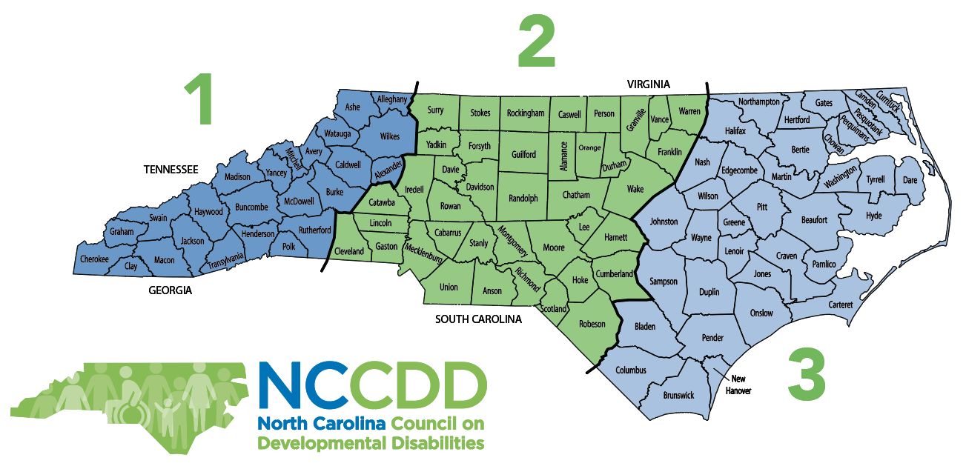

- What do you think are the three (3) most important issues for people with I/DD in North Carolina right now?
Check up to 3.

School | Employment
Housing | Transportation
Money and finances | Planning for the future
Knowing their rights | Self-Advocacy
Knowing what services and supports are available | Getting the services and supports needed
Getting good medical care | Technology to help someone do the activities they want
Living more independently | Helping people with disabilities move out of institutions
Doing more activities the individual likes | Having friends and meaningful relationships
Being more a part of the community | Other (please describe):

Community Services and Supports

- Effective coordination among paid services and supports is important. In your experience, are services between support systems (school, state, providers, Medicaid, family) coordinated well?
- No
- Somewhat
- Yes
- Don’t know

3) Do families and individuals with I/DD in your area have to wait to receive services and supports?
- No, they seldom have to wait
- Sometimes, or some people, have to wait
- Yes, they often have a long wait
- Don’t know

4) In your experience, do individuals with I/DD in your area currently receive enough help to do what they need and want to do?
- Yes, they have what is needed
- No, they need a little more help
- No, they need a lot more help each day
- No, they need more help almost all the time
- Don’t know/doesn’t apply

- In your experience, do family members of individuals with I/DD have the services and supports they need?
- Yes, family needs are mostly met
- Family needs are met somewhat or sometimes
- Families need considerably more support
- No, families are overwhelmed due to lack of support
- Don’t know

Technology
Some people are able to participate more in their communities with technology. Examples are iPad, voice-activated e-mail, screen readers, eye-gaze sensors, apps.

6) Do individuals with I/DD in your area have the assistive technology they need to participate in the community?
- No
- Somewhat, or some individuals
- Yes
- I don’t know enough about what technology might be helpful
- Don’t know/doesn’t apply

7) If you said no to the question above, what other technology is needed?: _______________________________________________________________________
________________________________________________________________________

Education and Learning
8) Do the schools in your area do a good job of preparing individuals with I/DD for adulthood?
- No, a big change is needed
- Some change is needed
- Yes, it’s about right – no change is needed
- Don’t know

9) How can schools prepare students better for adulthood?
_________________________________________________________________________________
_________________________________________________________________________________

10) Do schools in your area do a good job of preparing individuals with I/DD to have a job or go to college?
- No, a big change is needed
- Some change is needed
- Yes, it’s about right – no change is needed
- Don’t know

Jobs and Money
11) How important is it to you that individuals with I/DD be paid at least minimum wage ($7.25 an hour) for employment?
- It is very important
- It is somewhat important
- It is not important to me
- Don’t know

12) How common is it for the people with I/DD in your area of the state to work?
- Not common
- Somewhat common
- Very common
- Don’t know

13) How common is it for the people with I/DD in your area who are employed to receive at least minimum wage ($7.25 an hour) and work in an integrated setting (with people with and without disabilities)?
- Not common
- Somewhat common
- Very common
- Don’t know

14) Do people in your area with I/DD have the help they need to find a job?
- No
- Sometimes or some people
Yes
- Don’t know

15) Do people in your area with I/DD who have jobs typically have the job they want?
No, these are not typically jobs the individuals want
Some individuals have the jobs they want
Yes, these are typically jobs the individuals want
Don’t know/doesn’t apply

Health and Wellbeing
16) Do the individuals in your area with I/DD have friends and caring relationships with people other than support staff and family members?
- No, most individuals with I/DD have relationships with only staff and family
- Many individuals with I/DD have only one friend/relationship with people other than staff and family
- Yes, most individuals with I/DD have relationships with people other than staff and family
- Don’t know

17) Are people in your area with I/DD able to see a doctor when they need to do so?
Check all that apply.
- No, they do not have insurance
- No, they cannot afford a doctor
- No, they do not have a doctor to go to
- No, they cannot get to the doctor because of a lack of transportation
- Sometimes, or some people
Yes
Don’t know/this doesn’t apply to me.

18) Do you think most emergency personnel (police officers, firefighters, E.R. staff) in your area know enough about individuals with disabilities?
- No, they need a lot more training
- They need some more training
- Yes, it’s about right
- Don’t know

Self-Advocacy and Leadership
Self-advocacy means that individuals can speak up for themselves, know their rights, and advocate.

19) What would help individuals with I/DD and their families be better self-advocates and advocates?
Check all that apply.
- Training about self-advocacy/advocacy
- Knowing other self-advocates/advocates
- Meetings and conferences about self-advocacy/advocacy
- Self-advocacy/advocacy practice at school
- More information and training on the issues important to people with I/DD
- Transportation to events and meetings with leaders
- More advocacy events
- Don’t know/doesn’t apply to individuals with I/DD or their family members in my area

20) What would help you be a better advocate on I/DD issues?
Check all that apply.
- Training on advocacy
- Knowing other advocates and self-advocates
- Meetings and conferences about advocacy
- More information and training on the issues important to people with I/DD
- Transportation to events and meetings with leaders
- More advocacy events
- Don’t know/doesn’t apply

21) How do individuals with I/DD in your area learn about personal rights? They learn about rights...
Check all that apply.
- From their families
- At school
- From other self-advocates
- At meetings and conferences
- From the North Carolina Council on Developmental Disabilities (NCCDD) and/or other advocacy organizations
- Most don’t know about rights
- Don’t know/doesn’t apply to individuals with I/DD in my area

Homes
22) In general, do people with I/DD in your area of the state have the housing they want?
- No
- Sometimes, or some people
- Yes
- Don’t know

23) Do individuals with I/DD choose where they live?
- No opportunity to choose
- Sometimes or some people have opportunity to choose
- Yes, complete opportunity to choose
- Don’t know/doesn’t apply to individuals with I/DD in my area

24) Do individuals with I/DD in your area choose who they live with?
- No opportunity to choose
- Sometimes, or some people have opportunity to choose
- Yes, complete opportunity to choose
- Don’t know/doesn’t apply to individuals with I/DD in my area

25) How could housing for people with disabilities be better in your community?
_____________________________________________________________________

Transportation
26) How often do individuals with I/DD have access to adequate transportation to get where they want and need to go?
- Never
- Hardly ever
- Sometimes
- Most of the time
- Always
- Don’t know/doesn’t apply to individuals with I/DD in my area

27) How could transportation for people with disabilities be better in your community?

_______________________________________________________________________________
_______________________________________________________________________________

Family Support Services and Advocacy
Many individuals with I/DD live with their families. These families may need services and supports to meet the needs of their family member with I/DD. Families should also have the opportunity to be meaningfully involved in policy and decision making at all levels.

28) In general, are sufficient services and supports available to families of people with I/DD?
- No, limited or no services or supports
- Some services or supports
- Yes, a range of services or supports
- Don’t know

29) In general, do families of individuals with I/DD have the support they need to plan for the future?
- No, they need support to plan
- They have some support
- Yes, they have about the right support
- Don’t know

30) Do families of individuals with I/DD in your area have an opportunity to be involved in advocating on public policy issues and decisions related to people with I/DD?

- No opportunity to be involved
- Some opportunity to be involved
- Yes, they have opportunity to be involved
- Don’t know

Follow-Up to This Survey:
What are three (3) things you would most like to change or improve for people with disabilities in North Carolina?
Type one or two words on each line.
1. ______________________________________________________________________________________
2. ______________________________________________________________________________________
3. ______________________________________________________________________________________

Did these questions let us know what is important to you?
- No, they did not
- Some questions did
- Yes, they did
- Don’t know/doesn’t apply to me

Additional Comments – What Do We Need to Know
_________________________________________________________________________________________
_________________________________________________________________________________________
_________________________________________________________________________________________

COVID-19 Emergency
As we developed this survey, the COVID-19 (coronavirus) emergency was beginning in North Carolina. Please tell us anything we need to know about the experiences of people with I/DD in your community. For example, have they had all the help and information they needed? If not, what else has been needed?

_______________________________________________________________________________________
_______________________________________________________________________________________
________________________________________________________________________________________

_______________________________________________________________________________________
_______________________________________________________________________________________
________________________________________________________________________________________

_______________________________________________________________________________________
_______________________________________________________________________________________
________________________________________________________________________________________

Thank you again for your participation in our survey. We value and appreciate your input.
If you would like to request an alternative format or if you have questions about the 5 Year State Plan development process, please contact David Ingram at 1-800-357-6916 or David.Ingram@dhhs.nc.gov. This survey was developed by the North Carolina Council on Developmental Disabilities. This effort is supported by NCCDD and funds it received through P.L. 106-402, the Developmental Disability Assistance and Bill of Rights October 2000.

Please email the completed form to: NCFYP@nccdd.org
or mail to:
North Carolina Council on Developmental Disabilities
ATTN: Five Year Plan
2010 Mail Service Center
Raleigh, NC 27699

