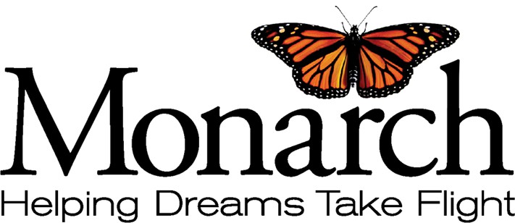

June 25, 2024

North Carolina Council on Developmental Disabilities ATTN: NCCDD Advocacy and Leadership Awards 2010 Mail Service Center

Raleigh, NC 27699-2010

Members of the Awards Selection Committee:

Pam Shipman has dedicated her life and career to serving people with intellectual and developmental disabilities (I/DD). While her professional path led to positions of leadership and significant responsibility, Pam remains committed to being a voice for people with disabilities and their families and to prioritizing the needs of individuals so they can lead meaningful, productive lives.

Pam is a tireless advocate for individuals and families. She understands the system and is willing to speak on their behalf. In just one example of many, Pam has been a long-time advocate for a young woman with I/DD who also a stoma that, due to funding limitations, prevents her from receiving care. Pam has attended meetings, explained the care needed and effectively illustrated how a provider could do this.

While funding remains an issue, Pam continues to advocate for this young woman, never stopping her

crusade, and often assisting the family by providing care for them for respite.

During her tenure as CEO of Piedmont Behavioral Health, Pam was frustrated with the current system that was unfair and inequitable. She tried to talk the state into allowing her more control over service allocation than they were willing to give. She realized that she could serve more people with Medicaid money if she had the ability to create a new system that was more equitable. At the time, two individuals with the same types of needs could get vastly different sums of money, depending primarily on how strong an advocate the family of the individual was.

In the late 1980s, Pam actually reached out to the Federal Government and created a three-way agreement between the state of NC, the federal government, and Piedmont LME. With Dan Coughlin, the CEO of Piedmont, Pam created Piedmont into a managed care company and brought equity into the system. Thousands of people with I/DD received increased services. In just the first year, she proved that she could save the state $17 million, while serving more people with improved care. Her results and data were incredible and visionary. She brought equity to the system. No longer did it depend on how loud someone complained. Services were awarded based on need.

Other LMEs were interested. What was most significant is that Pam was able to get the entire legislature to see her results, and five years after her pilot began, the legislature mandated that every LME become a managed care entity. That has led us to the incredible achievement of the Tailored Plan being rolled out this year. It is fitting that this year to honor Pam, as her efforts over 20 years ago were the beginning of what we know as the Tailored Plan today.

After her work at Piedmont, For some time, Pam worked for Monarch as an advocate, educating the North Carolina General Assembly about critical issues like direct support workforce salaries. She has incredible knowledge of the I/DD system, and she uses that knowledge to work directly with families to

get the support they need. She continues to be a leader in shaping ideas and solutions that are important to the people of this state. She often does things without compensation, simply because it is the “right” and ethical thing to do. She has an incredible heart.

Pam Shipman is a kind, caring individual and is highly deserving of the [Helen C. "Holly" Riddle](https://nccdd.org/the-council/advocacy-and-leadership-awards.html#holly) [Distinguished Service Award**.**](https://nccdd.org/the-council/advocacy-and-leadership-awards.html#holly)

Sincerely,

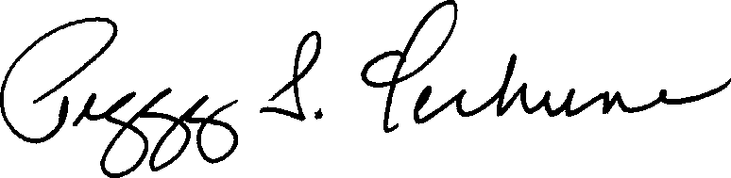

Peggy S. Terhune, Ph.D., M.B.A, OTR/L President and Chief Executive Officer