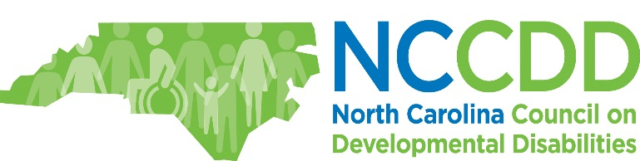

Agenda | Making Work WORK for Families and Guardians | September 22, 2017

8:00-9:00 Registration | 9:00-9:10 Welcome, Logistics, and Keynote Speaker Introduction: Philip Woodward & Travis Williams, North Carolina Council on Developmental Disabilities (NCCDD)
9:10-10:10 Keynote Speaker: “Great Expectations: Alternatives to Guardianship”: Holly Stiles, Lead Attorney, Community Access Team, Disability Rights North Carolina (DRNC)
10:10-10:30 BREAK
10:30-11:30 Panel: “How Finances Impact Working and Guardianship” Moderator: Travis Williams, Systems Change Manager, NCCDD
- Mary Buonfiglio, Deputy Director, & Catherine Jarboe, Communications Officer, Supplemental Retirement Plans, North Carolina Department of State Treasurer
- Donna Gallagher, Executive Director, The Collaborative
- Ava Bennett and Barbara Wilder, Work Incentives Benefits Counselors, North Carolina Division of Vocational Rehabilitation Services (DVRS)
- Adonis Brown, Individual with a Developmental Disability and Upward to Financial Stability Master Trainer
11:30-1:15 Buffet Lunch | “Speed Dating” Information Gathering and Networking
1:15-2:15 Panel: “Understanding Guardianship and Families and How They Impact Work”: Moderator: Philip Woodward, Systems Change Manager, NCCDD
- Gerri Smith, Assistant Director of Advocacy and Chapter Services, The Arc of North Carolina
- Corye Dunn, Director of Public Policy, Disability Rights North Carolina (DRNC)
- Laura Newell, Administrative Peer Mentor, InReach, and Founder of Self-Advocates of Mecklenburg Membership Organization
2:15-2:30 BREAK
2:30-3:30 Panel: “Taking Guardianship to the Next Level with Employment” Moderator: Pat Keul, I/DD Employment Services Coordinator, NCCDD
- Philip Woodward, Systems Change Manager, North Carolina Council on Developmental Disabilities (NCCDD)
- Sheena Gadis, Vocational Rehabilitation Counselor, Division of Services for the Blind (DSB)
- Jeffrey Payne, Director, I/DD Care Coordination, Alliance Behavioral Healthcare
- Britton Scercy, Office Assistant, Autism Society of North Carolina, & Jill Scercy, Greenville Center Director, UNC TEACCH Autism Program
3:30-4:30 Closing Keynote: “Encouraging Employment First Among People Under Guardianship”: David Ingram, I/DD Employment Specialist, North Carolina Division of Mental Health, Developmental Disabilities and Substance Abuse Services (DMH/DD/SAS)

List of Agencies/Organizations Providing Information
- Acting Is Awesome
- Alliance Behavioral Healthcare
- Disability Rights North Carolina (DRNC)
- North Carolina Department of State Treasurer
- North Carolina Division of Services for the Blind (DSB)
- North Carolina Division of Vocational Rehabilitation (DVRS)
- The Arc of North Carolina
- The Collaborative
- UNC TEACCH Autism Program
- Wake Technical Community College

